1 Model & Photos

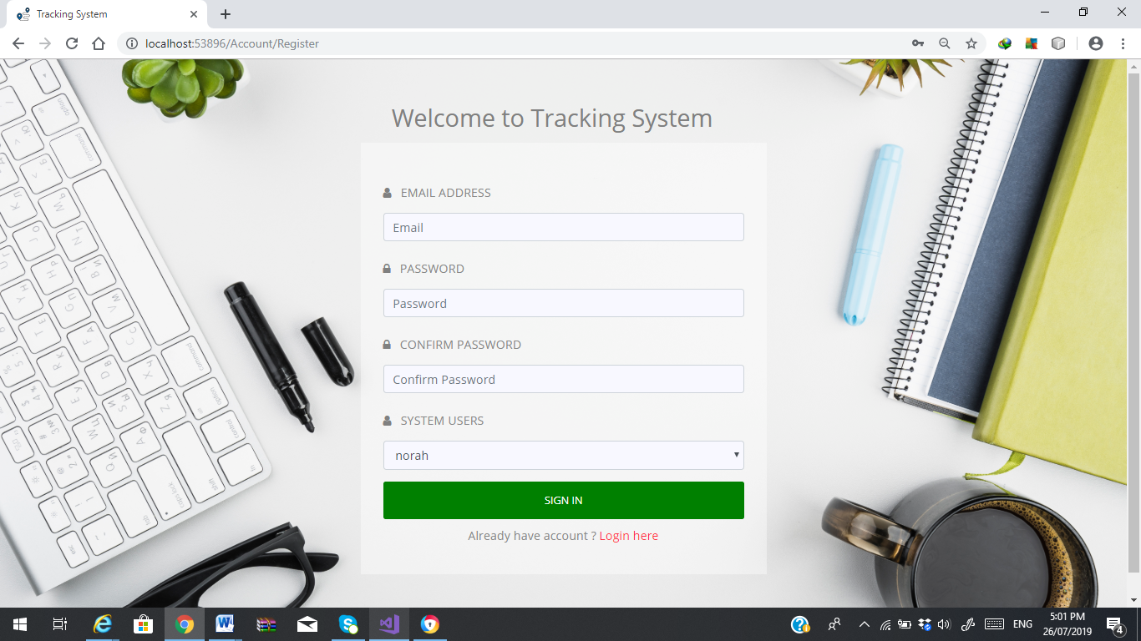

Figure 1.1 Registration Page

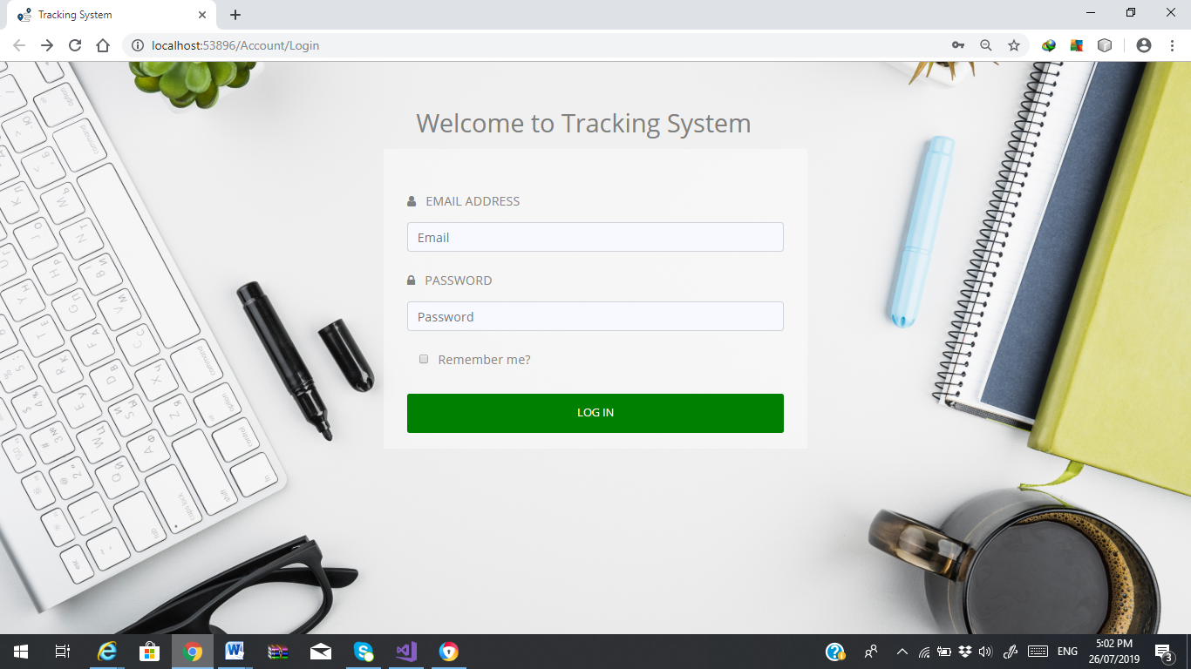

Figure 1.2 Login Page

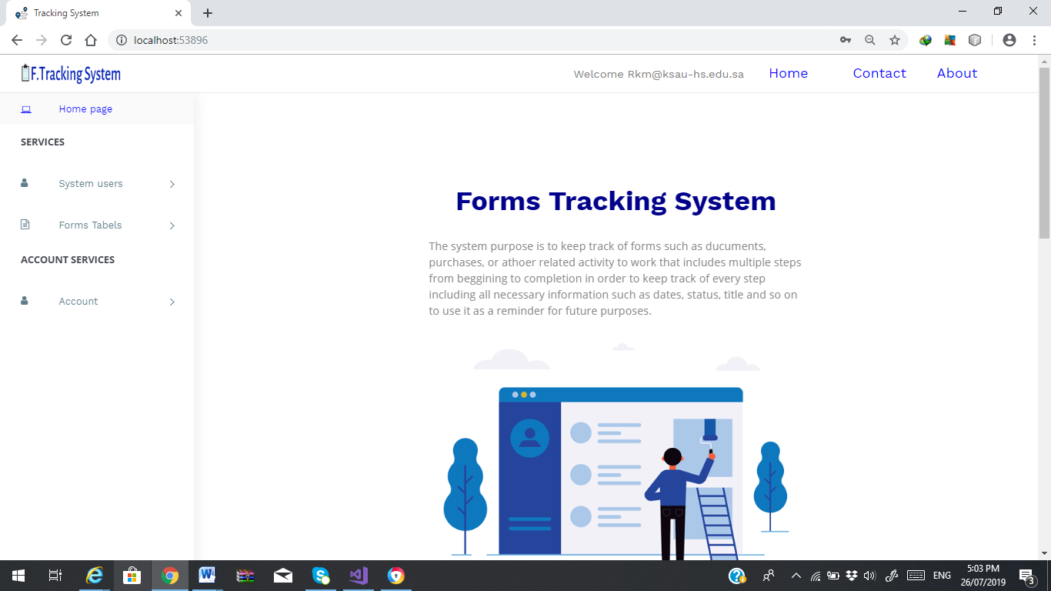

Figure 1.3 Welcome Home Page

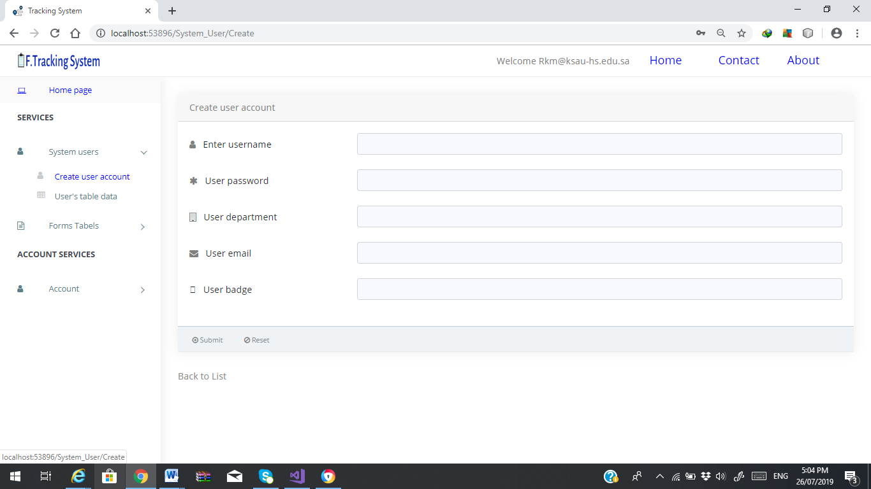

Figure 1.4 Create User Account Page

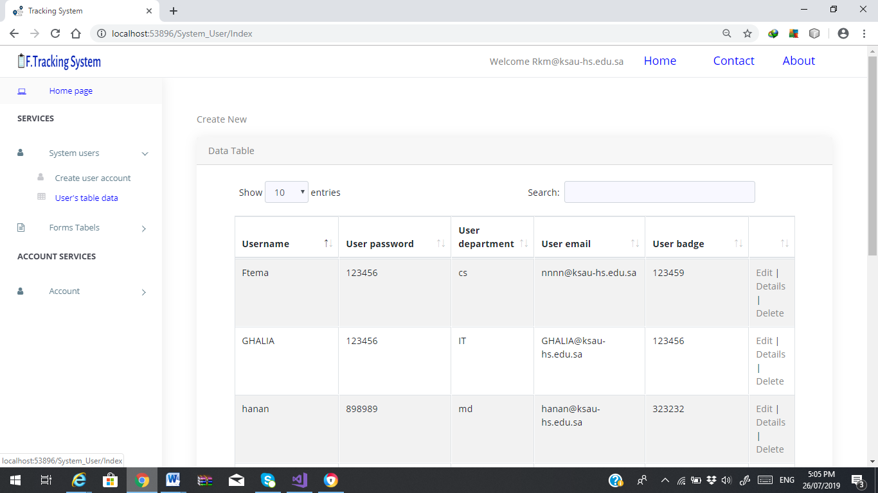

Figure 1.5 View Table User Account Page

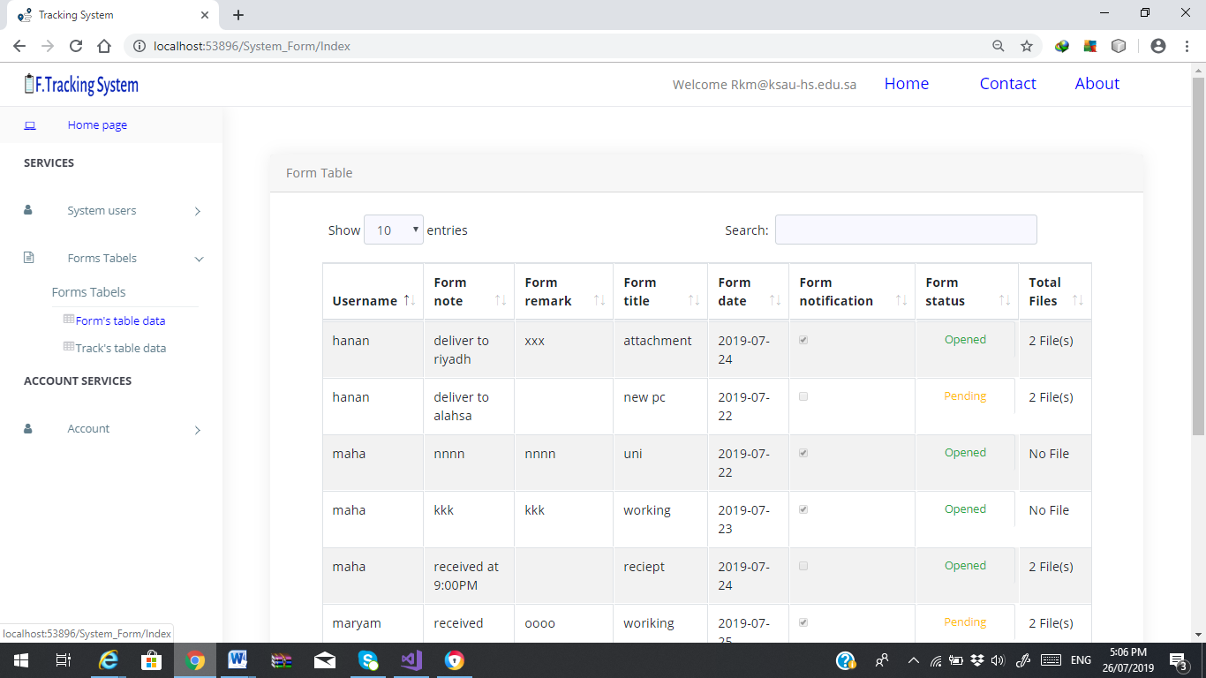

Figure 1.6 View Table Forms Page

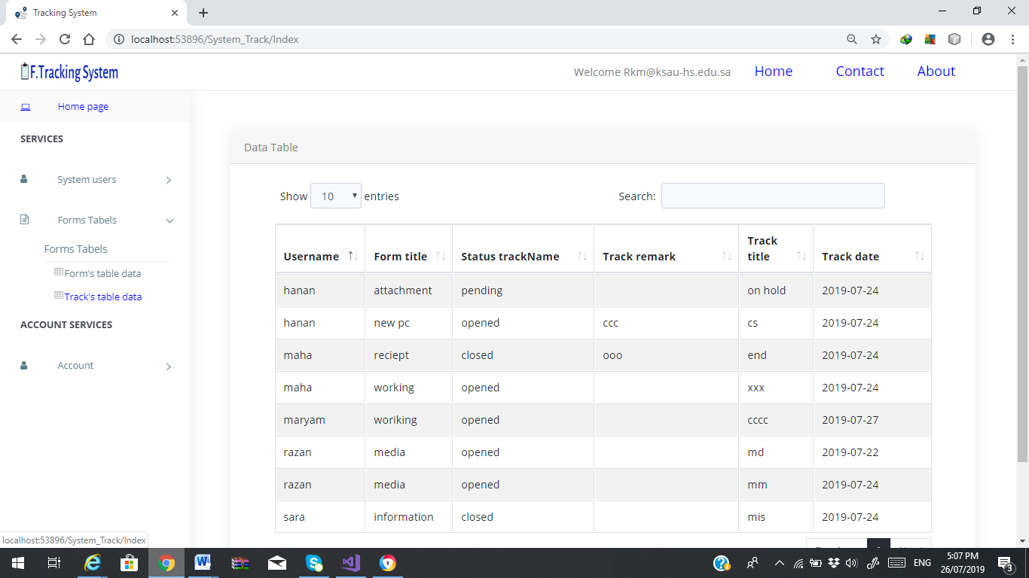

Figure 1.7 View Tracks Forms Page

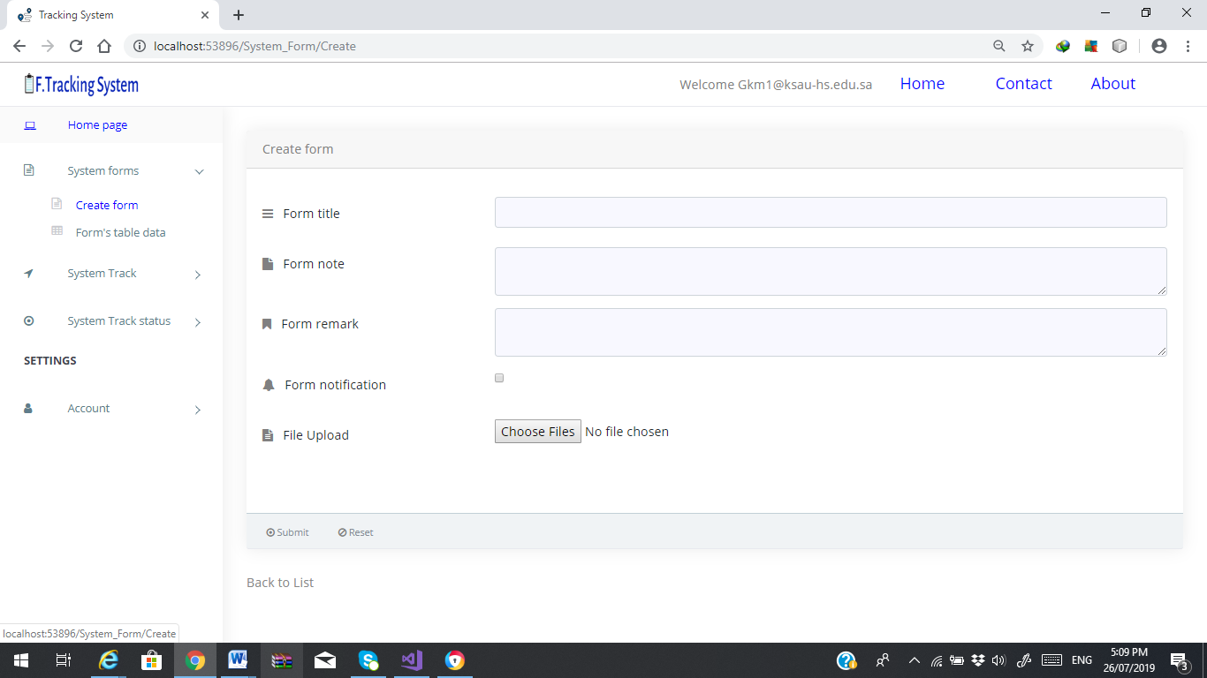

Figure 1.8 Create Form Page

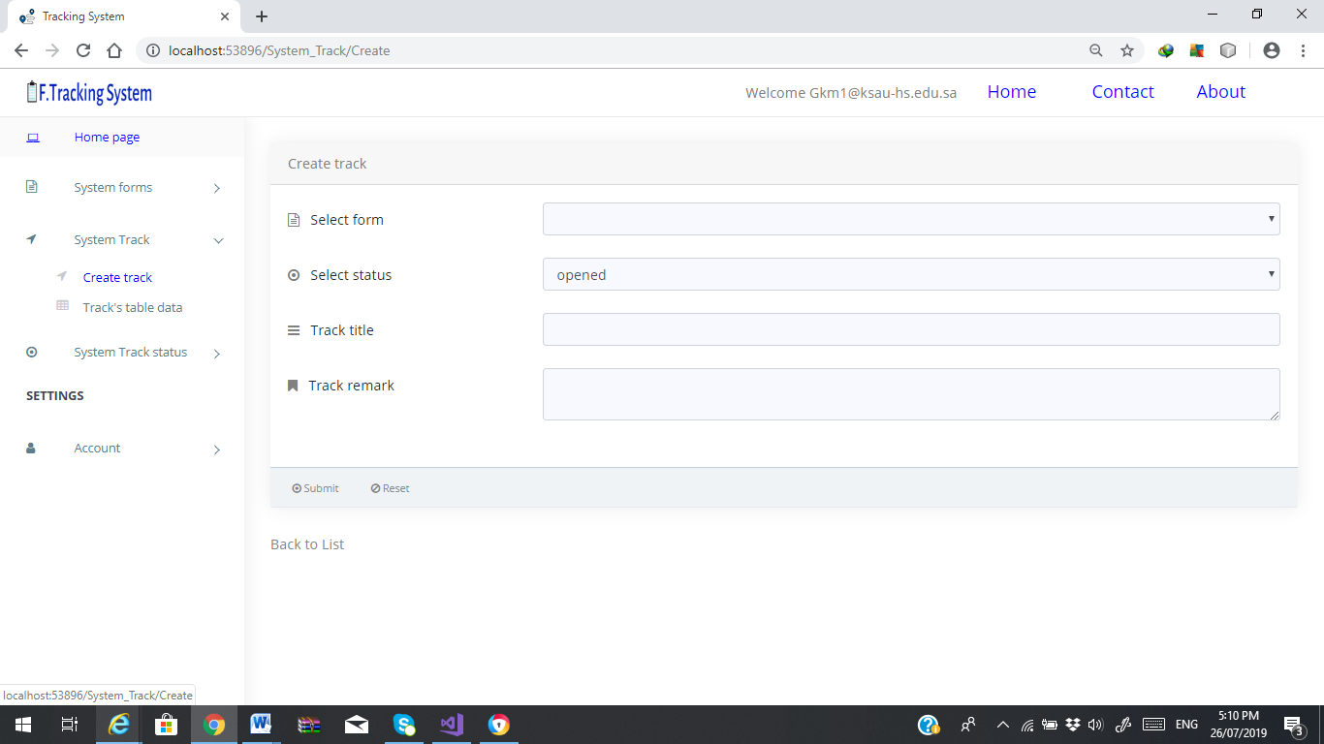

Figure 1.9 Create Track Page

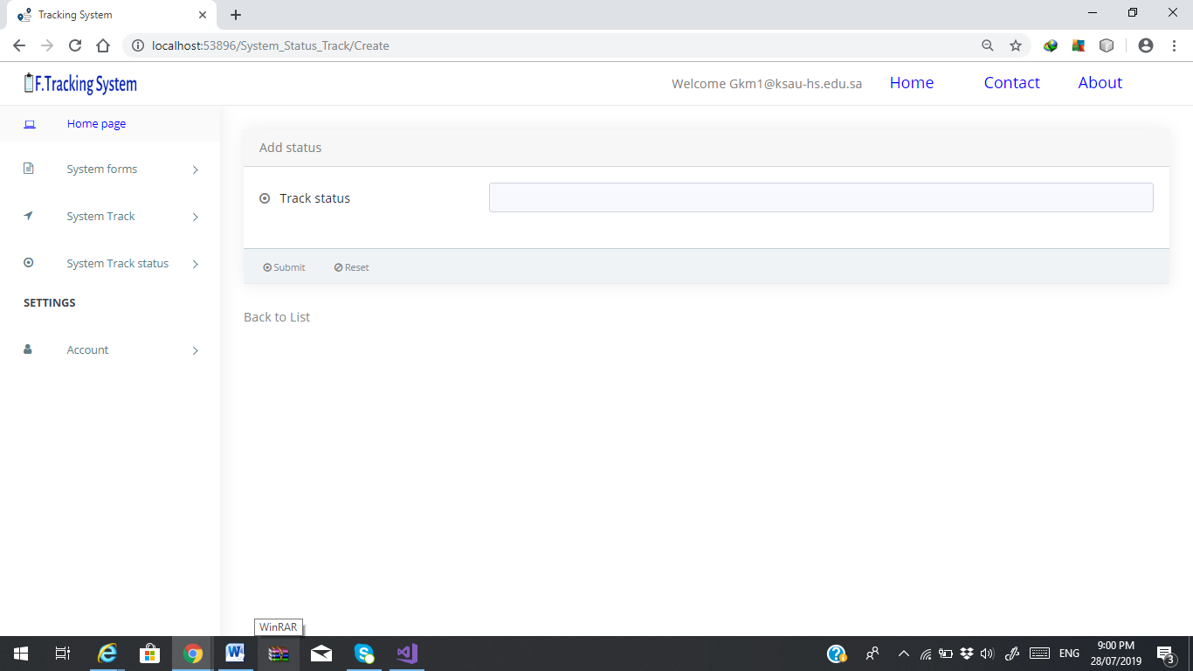

Figure 1.10 Create Status Track Page

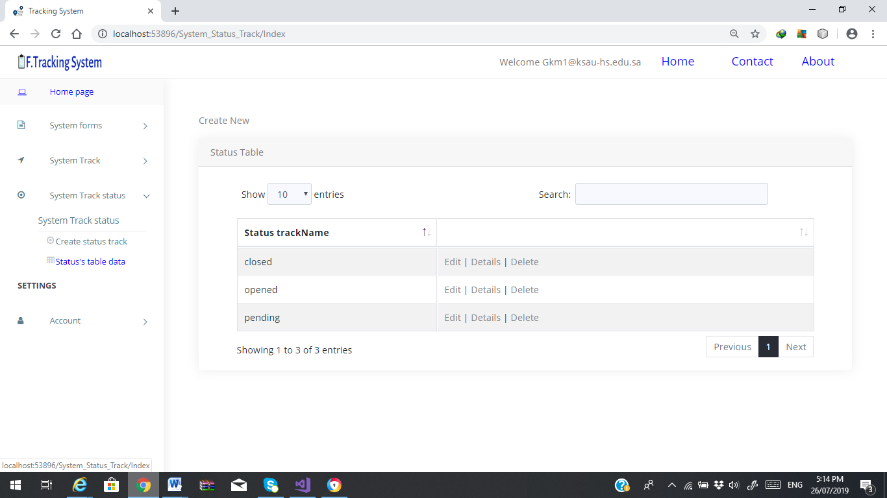

Figure 1.11 View the Status Track Page